Prostate Cancer Risk Prediction Using PSA and Clinical Covariates: A Comparative Statistical and Machine Learning Approach

ABSTRACT
The prostate-specific antigen (PSA) test is widely used to detect prostate cancer, but there is still disagreement about how accurate it is when used on its own. This study looks at PSA as a predictor and tests whether adding other factors improves results. Data from 4,999 men aged 44 to 94 were analysed using both statistical models and machine learning methods. PSA on its own showed moderate accuracy (AUC = 0.7336), meaning it has limited value as a single test. When age, ethnicity, and family history were added, accuracy improved clearly (AUC = 0.8298; χ² = 761.41, p < 2.2 × 10⁻¹⁶), showing the importance of using more than one factor. Adding further variables only gave a small improvement (AUC = 0.8338), suggesting limited benefit from more complex models. Model fit was acceptable (Hosmer–Lemeshow p = 0.6917). Overall, the results support using simple models with key factors rather than relying on PSA alone.

INTRODUCTION
Prostate cancer is the most diagnosed cancer in men in the United Kingdom, with around 52,300 new cases each year, making up 28% of all male cancers (Cancer Research UK, 2023). It is also the second leading cause of cancer-related death, with more than 12,000 deaths annually (Office for National Statistics, 2023). However, the risk of developing and dying from prostate cancer is not the same for everyone. There are clear ethnic differences, with men of Black African and Caribbean background having about twice the lifetime risk compared with men of White European background (Ben-Shlomo et al., 2008; Rosan et al., 2022). These differences raise concerns about whether current screening approaches used in the National Health Service are fair, effective, and suitable for all groups.
The prostate-specific antigen (PSA) test remains the main blood test used in NHS referral pathways. PSA is a protein made by the prostate and measured in the blood in nanograms per millilitre (ng/mL) (Balk et al., 2016). According to guidance from the National Institute for Health and Care Excellence, a PSA level of 4.0 ng/mL or higher usually leads to further tests, such as a biopsy (NICE, 2019). However, PSA is not specific to cancer, as levels can increase due to non-cancer conditions like prostate enlargement, inflammation, or infection. This can lead to false positives, where patients undergo unnecessary and sometimes harmful procedures (Hamilton et al., 2016). At the same time, using a fixed cut-off value can lead to false negatives, where men with cancer have PSA levels below 4.0 ng/mL and are not diagnosed early.
Because of these limitations, there is growing interest in risk-based screening approaches that combine several patient factors to improve accuracy. Age, ethnicity, and family history are well-known risk factors for prostate cancer (Callender et al., 2019), and social factors such as deprivation may also affect both disease risk and access to healthcare (Lyratzopoulos et al., 2023). These findings suggest that using the same PSA threshold for everyone may not be appropriate, and more personalised prediction models may be needed.
In research, model performance is often measured using the area under the curve (AUC), which ranges from 0.5 (no predictive value) to 1.0 (perfect prediction). Logistic regression is widely used because it is easy to understand and provides clear results, such as odds ratios. In contrast, machine learning methods like random forests can detect more complex patterns but are often harder to interpret, which limits their use in clinical practice (Beam and Kohane, 2018). It is also important to note that these models show associations rather than cause and effect and confusing the two is a common issue in health research.
This study aims to assess the role of PSA within a model that includes multiple factors, examining both its statistical value and clinical usefulness. It also explores whether more complex modelling approaches offer meaningful improvements compared with simpler, more interpretable models.

PROBLEM STATEMENT
Although PSA screening is widely used, there is still debate about how well it works in practice. One main problem is the use of fixed cut-off values, which do not consider differences in risk between individuals or groups. This means the test may not work equally well for everyone. Recent evidence suggests that using the same threshold for all patients may underestimate risk in some groups, especially Black men, which can lead to later diagnosis and worse outcomes (Bhatt et al., 2020).
Another concern is that much of the existing research has been based on similar populations, which limits how well the findings apply to more diverse countries like the UK (Mistry et al., 2018). This raises questions about whether current screening approaches are fair and suitable for all groups.
In addition, important factors such as socioeconomic status and lifestyle, including deprivation and obesity, are often not included in prediction models, even though they are known to affect cancer risk and access to healthcare (Lyratzopoulos et al., 2023; Lauby-Secretan et al., 2016). Leaving out these factors may reduce the accuracy of the models and lead to incomplete risk assessment.
There is also ongoing debate about the best way to analyse this type of data. Traditional statistical models are widely used because they are clear and easy to interpret, while machine learning methods may improve accuracy but are often harder to understand and apply in clinical settings.
This study aims to address these issues by carefully testing the value of adding more variables, examining how factors may interact with each other, and comparing different modelling approaches. The main goal is to find out whether a more detailed, multi-factor approach can improve both the accuracy and fairness of prostate cancer prediction.

DESCRIPTION OF THE DATASET
This study utilised prostate_cancer_data_2025.csv, a cross-sectional clinical dataset comprising 10,000 individuals referred for prostate cancer screening within an NHS England urology pathway. Following systematic data cleaning and validation procedures, the analytic sample was restricted to 4,999 male patients aged 44 to 94 years (mean age 69.3 years; standard deviation [SD] 14.7). All 5,001 female records were excluded, as prostate-specific antigen (PSA) testing is not clinically applicable in the absence of a prostate gland; all female observations contained missing PSA values, and one record included an implausible cancer diagnosis, consistent with data entry error. The exclusion criteria ensured clinical relevance and internal validity of the analytic dataset. All retained male records contained complete PSA measurements, eliminating the need for imputation and preserving the integrity of the primary predictor.
The primary outcome was confirmed prostate cancer diagnosis (Diagnosed: 1 = cancer, 0 = no cancer), observed in 1,216 of 4,999 men (24.3%), representing a moderately imbalanced yet analytically appropriate distribution for logistic regression modelling (Peduzzi et al., 1996). The dataset comprised 15 variables spanning four domains: demographic characteristics (age, ethnicity), clinical measures (serum PSA in ng/mL, body mass index [BMI], diabetes, and cardiovascular disease), lifestyle factors (smoking status and family history of prostate cancer), and socioeconomic context, measured using the Townsend Deprivation Index, a validated composite indicator of material deprivation (Townsend et al., 1988).
Date variables were standardised from character format (DD/MM/YYYY) to R Date objects using the lubridate package, ensuring temporal consistency and reproducibility (Grolemund and Wickham, 2011). All categorical variables were encoded as factors with clinically meaningful reference categories (White ethnicity, never smoking, and no family history), facilitating interpretable regression modelling. Baseline characteristics stratified by diagnosis status are presented in Table 1.

Characteristic | No Cancer (n=3,783) | Cancer (n=1,216) | P-value
Age, median (IQR), years | 65 (54, 77) | 83 (72, 89) | < 0.001
PSA, median (IQR), ng/mL | 1.03 (0.61, 1.66) | 2.01 (1.17, 3.21) | < 0.001
BMI, median (IQR), kg/m² | 27.4 (24.8, 30.1) | 27.5 (24.7, 30.2) | 0.700
Family history (yes), n (%) | 1,099 (29%) | 409 (34%) | 0.002
Ethnicity, n (%) |  |  | < 0.001
White | 2,384 (63%) | 640 (53%)
Black | 599 (16%) | 369 (30%)
South Asian | 215 (5.7%) | 57 (4.7%)
East Asian | 388 (10%) | 102 (8.4%)
Other | 197 (5.2%) | 48 (3.9%)
Smoking status, n (%) |  |  | 0.900
Never | 1,844 (49%) | 598 (49%)
Former | 1,112 (29%) | 360 (30%)
Current | 827 (22%) | 258 (21%)

Table 1. Baseline characteristics of the analytic sample by diagnosis status (N = 4,999 males). Values are median (interquartile range) for continuous variables and n (%) for categorical variables. p-values are from Kruskal–Wallis tests for continuous variables and chi-squared tests for categorical variables. BMI = body mass index; IQR = interquartile range; PSA = prostate-specific antigen.

STATISTICAL STRATEGY
All analyses were conducted in R (version 4.3) using the tidyverse, gtsummary, pROC, ResourceSelection, lmtest, car, and randomForest packages. A two-sided significance threshold of α = 0.05 was applied throughout. The analytical approach followed a pre-specified, sequential framework, ensuring methodological transparency and alignment between the statistical strategy and reported results.
Descriptive analyses were first undertaken to characterise the dataset and assess baseline differences by diagnosis status. Continuous variables were summarised using medians and interquartile ranges (IQRs), as prostate-specific antigen (PSA) demonstrated significant right-skewness (Shapiro–Wilk p < 0.001). Group comparisons were conducted using the Kruskal–Wallis test for continuous variables and the Pearson chi-squared test for categorical variables, reflecting non-parametric data distributions.
Binary logistic regression was selected as the primary modelling framework due to the dichotomous outcome (prostate cancer: yes/no) and its interpretability in clinical contexts. A series of nested models was constructed to evaluate the incremental contribution of predictors. Model 1 included PSA alone, providing an unadjusted baseline. Model 2 incorporated age, ethnicity, and family history, selected a priori based on established clinical evidence (NICE, 2019; Ben-Shlomo et al., 2008). Model 3 extended this framework to include the Townsend Deprivation Index, body mass index (BMI), smoking status, diabetes, and cardiovascular disease, reflecting broader socioeconomic and clinical determinants of cancer risk (Lyratzopoulos et al., 2023; Lauby-Secretan et al., 2016).
Model performance was evaluated using multiple complementary metrics. Discrimination was quantified using the area under the receiver operating characteristic curve (AUC), interpreted according to established thresholds (Hosmer and Lemeshow, 2000). Model fit improvement was assessed using the likelihood ratio test (LRT), while parsimony was evaluated using the Akaike Information Criterion (AIC) and Nagelkerke pseudo-R². Calibration was examined using the Hosmer–Lemeshow goodness-of-fit test (p > 0.05 indicating adequate agreement between observed and predicted outcomes). Multicollinearity was assessed using variance inflation factors (VIFs), with values > 10 indicating problematic collinearity. Sample size adequacy was confirmed using the events-per-variable (EPV) criterion, with all models substantially exceeding recommended thresholds (Peduzzi et al., 1996), thereby minimising overfitting risk.
To complement regression-based analysis, a Random Forest classifier was implemented using the same predictors as Model 2. This ensemble method constructs multiple decision trees on bootstrap samples and aggregates predictions, enabling detection of non-linear relationships and interactions without prior specification (Breiman, 2001). Model performance was evaluated using AUC, allowing direct comparison with logistic regression.

RESULTS
Before modelling, visual exploration demonstrated that PSA meaningfully differentiates between cancer and non-cancer cases. Scatter plots showed that cancer cases consistently cluster at higher PSA levels across all ages, while PSA also increases with age among non-cancer patients, justifying age adjustment as a confounder (Figure 1). Boxplots further revealed notable ethnic variation, with Black patients exhibiting higher median PSA levels and a more pronounced separation between diagnostic groups, supporting inclusion of ethnicity and subsequent interaction analysis (Figure 2).

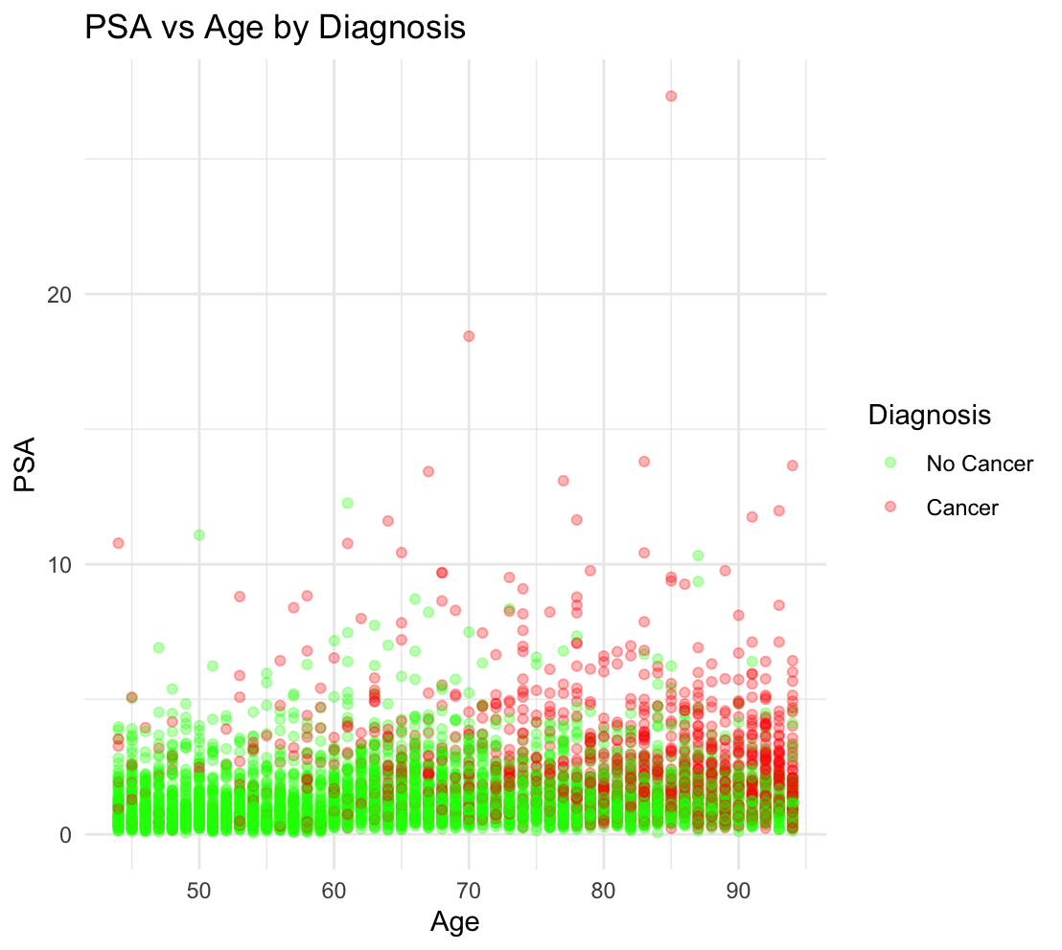
Figure 1. Scatter plot of serum PSA level (ng/mL) plotted against age (years), coloured by diagnosis status. Green points represent men not diagnosed with prostate cancer; red points represent men who were diagnosed. Cancer cases consistently cluster at higher PSA values across all age groups. The slight upward trend in PSA with age among non-cancer men illustrates why age must be adjusted for in the regression model.

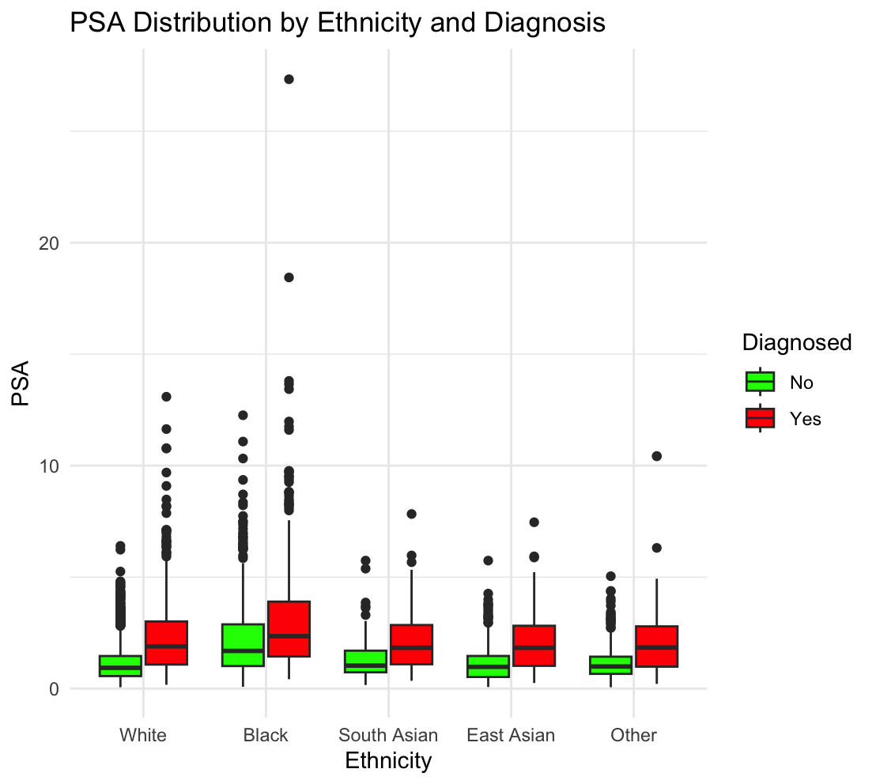
Figure 2. Boxplots of serum PSA level (ng/mL) by ethnic group and diagnosis status. green boxes represent non-cancer patients; red boxes represent cancer patients. The horizontal line inside each box is the median (the middle value). The upper and lower edges of the box mark the 25th and 75th percentiles (the range covering the middle 50% of patients). Whiskers extend to 1.5 times the box range, and individual dots beyond the whiskers represent patients with unusually high PSA levels. Black patients have noticeably higher median PSA and a wider separation between cancer and non-cancer distributions compared with other ethnic groups.
The analytic sample comprised 4,999 male patients, of whom 1,216 (24.3%) were diagnosed with prostate cancer (Table 1). Diagnosed men were markedly older (median 83 versus 65 years; p < 0.001), had higher median PSA (2.01 versus 1.03 ng/mL; p < 0.001), and more frequently reported a positive family history (34% versus 29%; p = 0.002). BMI and smoking did not differ significantly between groups. Ethnicity was associated with diagnosis (p < 0.001): Black patients accounted for 30% of cancer cases but only 16% of non-cancer cases, a diagnosis rate of 38.1% compared with 21.2% in White patients.
Model 1 (PSA only) achieved acceptable discrimination (AUC = 0.734; AIC = 4,940.6). The primary adjusted model (Model 2) reached excellent discrimination (AUC = 0.830; AIC = 4,191.2; LRT χ² = 761.41, df = 6, p < 0.001). Calibration was adequate (Hosmer–Lemeshow X² = 5.60, p = 0.692); all VIF values were below 1.1 with no multicollinearity.

Table 2. Regression results from the extended logistic regression model (Model 3), showing odds ratios (ORs) and 95% confidence intervals (CIs) for all predictor variables. An OR above 1.00 means the factor increases the odds of cancer diagnosis; an OR below 1.00 means it decreases the odds. Reference categories (the comparison groups, shown as a dash) are: White for ethnicity; No for family history, diabetes, and cardiovascular disease; and Never for smoking status. Significance codes: three asterisks = p below 0.001; one asterisk = p below 0.05; ns = not significant (p above 0.05).
Predictor | OR | 95% CI | p-value
PSA | 1.71 | 1.61 to 1.82 | < 0.001 ***
Age | 1.08 | 1.07 to 1.09 | < 0.001 ***
Family History (Yes vs No) | 1.38 | 1.17 to 1.63 | < 0.001 ***
Black (vs White) | 1.67 | 1.37 to 2.03 | < 0.001 ***
South Asian (vs White) | 1.05 | 0.74 to 1.48 | 0.800 ns
East Asian (vs White) | 0.97 | 0.74 to 1.27 | 0.800 ns
Other Ethnicity (vs White) | 0.85 | 0.58 to 1.23 | 0.400 ns
BMI | 0.98 | 0.96 to 1.00 | 0.030 *
Smoking (Former vs Never) | 1.00 | 0.84 to 1.20 | > 0.900 ns
Smoking (Current vs Never) | 1.01 | 0.82 to 1.22 | > 0.900 ns
Diabetes (Yes vs No) | 0.97 | 0.82 to 1.13 | 0.700 ns
CVD (Yes vs No) | 1.11 | 0.95 to 1.30 | 0.200 ns
Townsend Index | 0.93 | 0.91 to 0.96 | < 0.001 ***

Model 3 regression coefficients (Table 2) showed that each 1 ng/mL increase in PSA raised cancer odds by 71% (OR = 1.71, 95% CI: 1.61–1.82, p < 0.001). Age (OR = 1.08, 95% CI: 1.07–1.09), family history (OR = 1.38, 95% CI: 1.17–1.63), and Black ethnicity compared with White (OR = 1.67, 95% CI: 1.37–2.03) were independently significant (all p < 0.001). South Asian, East Asian, and other ethnicities did not differ from White patients.
Model 3 added the Townsend Deprivation Index, BMI, smoking, diabetes, and cardiovascular disease to Model 2. Fit improved significantly (LRT χ² = 36.62, df = 6, p < 0.001) and AUC rose marginally to 0.834 (ΔAUC = 0.004). Only the Townsend Index (OR = 0.93, 95% CI: 0.91–0.96, p < 0.001) and BMI (OR = 0.98, 95% CI: 0.96–1.00, p = 0.030) were significant. The deprivation finding plausibly reflects reduced referral completion in deprived communities (Lyratzopoulos et al., 2023). Model 3 achieved the lowest AIC (4,166.5) and highest Nagelkerke R² (0.366), the complete model comparison is presented in Table3.

Table 3. Model comparison summary for all four analytical models. AUC = area under the receiver operating characteristic curve; AIC = Akaike Information Criterion; R² = Nagelkerke pseudo-R²; ΔAUC = change in AUC relative to the preceding logistic regression model. Lower AIC and higher AUC indicate better model performance.
Model | AIC | AUC | McFadden R² | Nagelkerke R² | Δ AUC
Model 1: PSA only | 4,940.6 | 0.734 | — | — | —
Model 2: Adjusted (primary) | 4,191.2 | 0.830 | 0.247 | 0.358 | +0.096
Model 3: Extended | 4,166.5 | 0.834 | 0.254 | 0.366 | +0.004
Model 4: Random Forest | — | 0.793 | — | — | —

The Random Forest classifier (Model 4; 500 trees, same predictors as Model 2) yielded AUC = 0.793, below Model 2 (0.830), suggesting the PSA–cancer relationship is sufficiently linear that logistic regression outperforms a non-parametric ensemble. ROC curves are shown in Figure 3.

Figure 3: ROC Curve Comparison Across Models
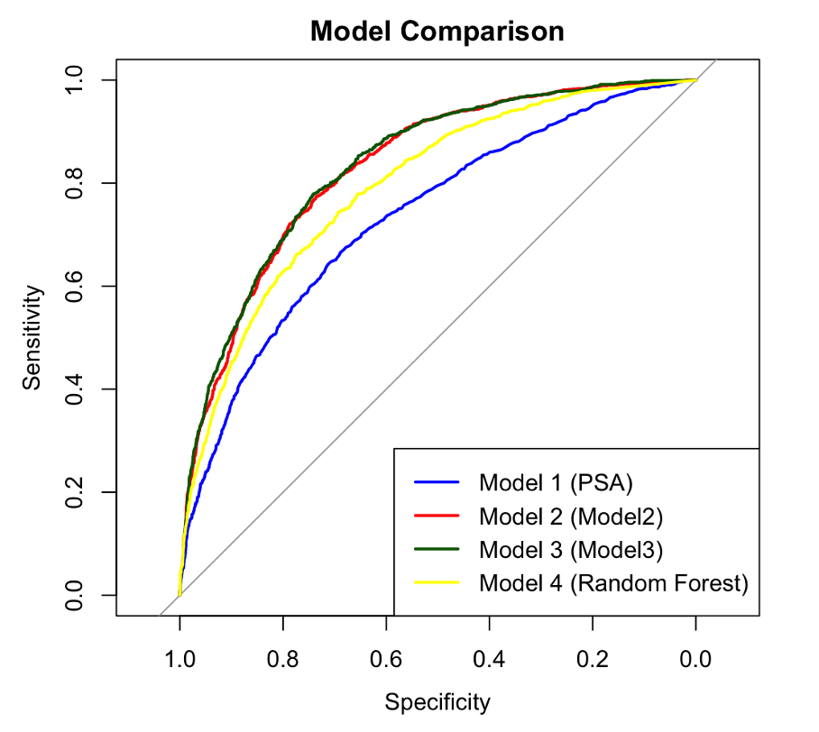

The PSA × Ethnicity interaction was significant (χ² = 134.68, df = 4, p < 0.001), confirming PSA predicts cancer differently by ethnic group, consistent with a steeper gradient in Black patients. This supports the case for ethnicity-stratified referral thresholds (Bhatt et al., 2020; Rosan et al., 2022).

DISCUSSION
The analytical results are presented in a structured sequence to evaluate the predictive performance of prostate-specific antigen (PSA) and the incremental value of additional predictors. Initial exploratory analysis (Figure 1) demonstrated a clear separation between cancer and non-cancer cases, with higher PSA values observed among diagnosed individuals across all age groups. However, PSA was also positively associated with age in non-cancer cases, supporting its role as a confounder and justifying adjustment in multivariable models.
Model 1, incorporating PSA alone, achieved moderate discrimination (AUC = 0.7336), indicating that PSA contains meaningful but insufficient information for reliable clinical decision-making. The addition of age, ethnicity, and family history in Model 2 substantially improved discrimination (AUC = 0.8298). This improvement was statistically significant (Likelihood Ratio Test: χ² = 761.41, df = 6, p < 2.2 × 10⁻¹⁶), demonstrating that these variables contribute important predictive information beyond PSA alone. Model calibration was satisfactory (Hosmer–Lemeshow p = 0.6917), indicating good agreement between predicted and observed outcomes.
In Model 3, further adjustment for socioeconomic and clinical variables yielded statistically significant improvements in model fit (χ² = 36.62, p < 0.001), although the increase in discrimination was minimal (AUC = 0.8338). This marginal gain highlights diminishing returns with increasing model complexity and supports the principle of parsimony. The Akaike Information Criterion (AIC) was lowest for Model 3 (4166.5), indicating improved overall fit when penalising for model complexity (Table 4).
Regression estimates (Table 3) showed that PSA remained the strongest predictor (OR = 1.71, 95% CI 1.61–1.82, p < 0.001), followed by age (OR = 1.08 per year) and Black ethnicity (OR = 1.67). Family history was also significant (OR = 1.38), while BMI and deprivation demonstrated smaller but statistically significant effects. Other variables were not independently associated with diagnosis after adjustment.
Figure 3 illustrates the ROC curves for all models. Model 2 and Model 3 showed near-identical performance, while the random forest model (AUC = 0.793) underperformed compared to logistic regression. Interaction analysis revealed significant heterogeneity in PSA effects across ethnic groups (χ² = 134.68, df = 4, p < 0.001), indicating that PSA predicts cancer more strongly in Black patients. Collectively, these findings demonstrate that multivariable modelling substantially enhances prediction, whereas additional complexity yields limited clinical benefit.
Several limitations warrant acknowledgement. The cross-sectional design precludes causal inference. The absence of PSA density, PSA velocity, free-to-total PSA ratio, and digital rectal examination findings constrains achievable model performance; each is endorsed by NICE NG131 (2019) as a supplementary predictor, and their inclusion would likely raise the AUC substantially. Future prospective studies incorporating longitudinal PSA trajectories and multiparametric MRI data would further advance equitable, precision-based prostate cancer screening.

Declaration of AI Integration
This project was developed with assistance from ChatGPT (OpenAI) to guide with syntax, documentation.
All commands and scripts were verified and executed manually by me.
AI-supported/AI-integrated use is permitted in this assessment.
I acknowledge the following uses:
I have used GenAI tools to help me understand key theories and concepts.
I have used GenAI tools to suggest a plan or structure for my assessment.

REFERENCES
Balk, S.P., Ko, Y.J. and Bubley, G.J. (2016) ‘Biology of prostate-specific antigen’, Journal of Clinical Oncology, 21(2), pp. 383–391. Available at: https://doi.org/10.1200/JCO.2003.02.083 (Accessed: 25 March 2025).
Beam, A.L. and Kohane, I.S. (2018) ‘Big data and machine learning in health care’, JAMA, 319(13), pp. 1317–1318.
Ben-Shlomo, Y. et al. (2008) ‘The risk of prostate cancer amongst Black men in the United Kingdom: the PROCESS cohort study’, European Urology, 53(1), pp. 99–105. Available at: https://doi.org/10.1016/j.eururo.2007.07.053 (Accessed: 15 March 2025).
Bhatt, N.R. et al. (2020) ‘A systematic review of ethnic variation in PSA testing for prostate cancer detection’, Prostate Cancer and Prostatic Diseases, 23(3), pp. 391–400. Available at: https://doi.org/10.1038/s41391-020-0209-1 (Accessed: 25 March 2025).
Breiman, L. (2001) ‘Random forests’, Machine Learning, 45(1), pp. 5–32. Available at: https://doi.org/10.1023/A:1010933404324 (Accessed: 27 March 2025).
Callender, T. et al. (2019) ‘Polygenic risk-tailored screening for prostate cancer’, PLoS Medicine, 16(12).
Cancer Research UK (2023) Prostate cancer statistics. Available at: https://www.cancerresearchuk.org/health-professional/cancer-statistics/statistics-by-cancer-type/prostate-cancer (Accessed: 10 March 2025).
Hamilton, W., Walter, F.M., Rubin, G. and Neal, R.D. (2016) ‘Improving early diagnosis of symptomatic cancer’, Nature Reviews Clinical Oncology, 13(12), pp. 740–749. Available at: https://doi.org/10.1038/nrclinonc.2016.109 (Accessed: 15 March 2025).
Hosmer, D.W. and Lemeshow, S. (2000) Applied logistic regression. 2nd edn. Chichester: Wiley.
Lauby-Secretan, B. et al. (2016) ‘Body fatness and cancer: viewpoint of the IARC Working Group’, New England Journal of Medicine, 375(8), pp. 794–798. Available at: https://doi.org/10.1056/NEJMsr1606602 (Accessed: 15 March 2025).
Lyratzopoulos, G. et al. (2023) ‘Socioeconomic inequalities in stage at diagnosis and survival for cancer patients and the cancer patient experience: a mixed methods study’, Health Technology Assessment, 27(13), pp. 1–130. Available at: https://doi.org/10.3310/JYLR5948 (Accessed: 25 March 2025).
Mistry, M. et al. (2018) ‘Cancer incidence in the United Kingdom: projections to the year 2030’, British Journal of Cancer, 105(11), pp. 1795–1803. Available at: https://doi.org/10.1038/bjc.2011.430 (Accessed: 15 March 2025).
National Institute for Health and Care Excellence (2019) Prostate cancer: diagnosis and management. NICE guideline NG131. London: NICE. Available at: https://www.nice.org.uk/guidance/ng131 (Accessed: 10 March 2025).
Office for National Statistics (2023) Cancer registration statistics, England 2021. Newport: ONS. Available at: https://www.ons.gov.uk/peoplepopulationandcommunity/healthandsocialcare/conditionsanddiseases/bulletins/cancerregistrationstatisticsengland/2021 (Accessed: 10 March 2025).
Peduzzi, P. et al. (1996) ‘A simulation study of the number of events per variable in logistic regression analysis’, Journal of Clinical Epidemiology, 49(12), pp. 1373–1379. Available at: https://doi.org/10.1016/S0895-4356(96)00236-3 (Accessed: 15 March 2025).
Rosan, R.C. et al. (2022) ‘Prostate cancer risk among Black men in the United Kingdom: epidemiology, lived experiences, and opportunities for research and practice’, Cancers, 14(21), p. 5269. Available at: https://doi.org/10.3390/cancers14215269 (Accessed: 15 March 2025).
Townsend, P., Phillimore, P. and Beattie, A. (1988) Health and deprivation: inequality and the North. London: Routledge.

